Unemployment rates remained stable in the majority of OECD countries in September 2025
Paris, 13 November 2025
Reference period: September 2025

In September 2025, the unemployment rate remained stable, compared to August 2025, in 24 of the 32 OECD countries with available data. Four OECD countries saw an increase, and four others experienced a decline (Table 1). Korea, Japan, Mexico, Czechia and Israel registered unemployment rates at or below 3.0%, with Korea’s unemployment rate marking a record low (at 2.5%). Only Spain recorded a double-digit unemployment rate (Figure 1 and Table 1). As several countries have not released their statistics for September 2025 yet, unemployment rates for the OECD and the G7 areas currently remain unavailable.*
In the European Union and the euro area, unemployment rates in September 2025 remained unchanged at 6.0% and 6.3%, respectively. Among the 17 OECD euro area countries, 13 saw stable unemployment rates in September 2025. Unemployment rates rose in Luxembourg and Slovenia, while Finland and Austria saw declines primarily due to falling unemployment rates among women aged 25 and over (Figure 4 and Table 1).
Outside the euro area, the unemployment rate was stable in most OECD countries in September 2025. Increases were observed in Hungary, primarily driven by men aged 25 and over, and in Australia, where women aged 15–24, men aged 15–24, and men aged 25-and-over contributed evenly to the rise (Figure 4 and Table 1). More timely estimates for Canada show that the unemployment rate declined 0.2 percentage points (p.p.) to 6.9% in October 2025.
In September 2025, the unemployment rate for men exceeded that of women in 20 OECD countries. Estonia, Belgium and Finland recorded the largest gap in favour of women, with unemployment rates for women at least 1.5 p.p. lower than those for men. Among OECD countries where women faced higher unemployment rates, Spain, Türkiye, and Greece showed the widest gap, each exceeding 3 p.p. (Figure 2 and Table 3).
The youth unemployment rate exceeded that of workers aged 25 and over in all OECD countries in September 2025 or in the latest period available. The smallest gaps, both under 1.5 p.p., were recorded in Israel and Japan, while the largest differences, exceeding 15 p.p., were recorded in Luxembourg, Spain, and Colombia (Figure 3 and Table 4).

Figure 1 – Unemployment rate for OECD countries
September 2025 (or latest period available) compared with lowest rate since 2001, percentage of labour force, seasonally adjusted
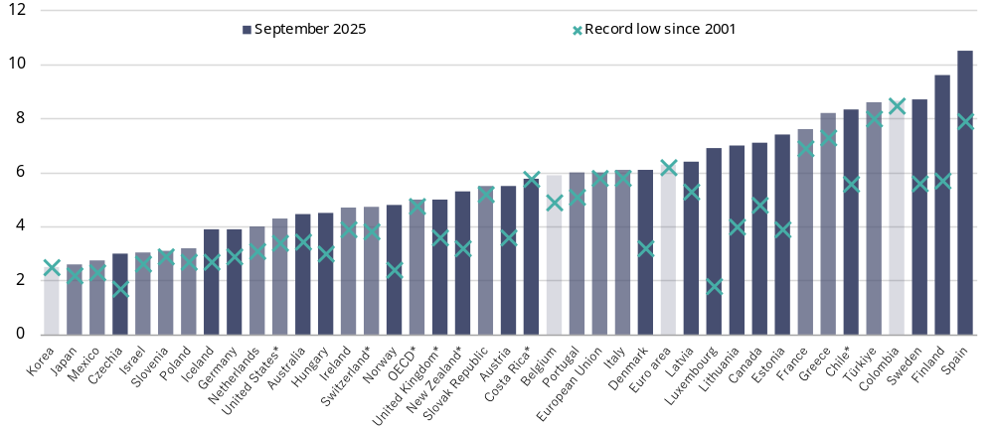
Note: The September 2025 unemployment rate was at or within 0.1 percentage points (p.p.)of its record low in Colombia, Costa Rica (August 2025), and Korea as well as in the euro area (bars reported in blue light). It was more than 1.0 p.p. above its record low in Australia, Austria, Belgium, Canada, Chile (August 2025), Czechia, Denmark, Estonia, Finland, Germany, Hungary, Iceland, Latvia, Lithuania, Luxembourg, New Zealand (Q3 2025), Norway, Spain, Sweden, and the United Kingdom (August 2025) (bars reported in dark blue).
* Due to missing data for Chile, Costa Rica, the United Kingdom, and the United States, September figures for the aggregate for the OECD area are not available yet. For these four countries, as well as for the OECD area, the unemployment rate for August 2025 is reported; for Switzerland, second quarter 2025; for New Zealand, third quarter 2025.
Source: OECD (2025) Infra-annual Labour Statistics, and Monthly unemployment rates.
Figure 2 – Unemployment rate by sex for OECD countries
September 2025 (or latest period available), percentage of labour force, seasonally adjusted
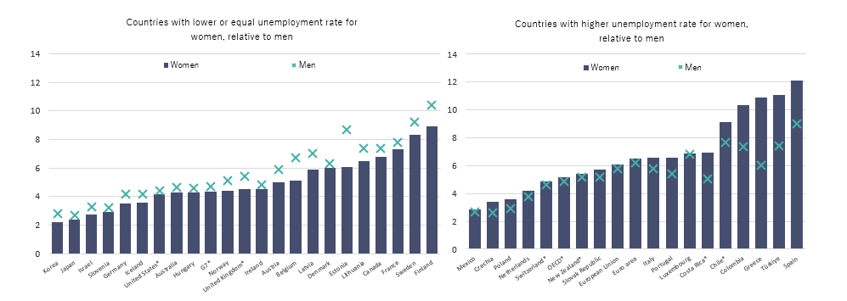
* Due to missing data for Chile, Costa Rica, the United Kingdom, and the United States, September figures for the aggregates for the OECD and the G7 areas are not available yet. For these four countries, as well as for the OECD and G7 areas, the unemployment rate for August 2025 is reported; for Switzerland, second quarter 2025; for New Zealand, third quarter 2025.

Figure 3 – Youth and adult unemployment rates to total unemployment rate for OECD countries
September 2025 (or latest period available), percentage of labour force, seasonally adjusted

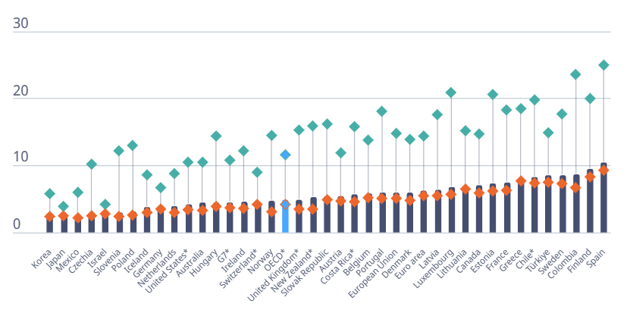
* Due to missing data for Chile, Costa Rica, the United Kingdom, and the United States, September figures for the aggregates for the OECD and the G7 areas are not available yet. For these four countries, as well as for the OECD and G7 areas, the unemployment rates (15+, 15-24, and 25+) for August 2025 is reported; for Switzerland, second quarter 2025; for New Zealand, third quarter 2025. Italy is not shown due to missing figures for one of the age groups for September 2025.
Source: OECD (2025) Infra-annual Labour Statistics and Monthly unemployment levels

Figure 4 – Decomposition by age and sex groups of the monthly variation in the unemployment rate
September 2025 (or latest period available), selected countries, percentage points, seasonally adjusted
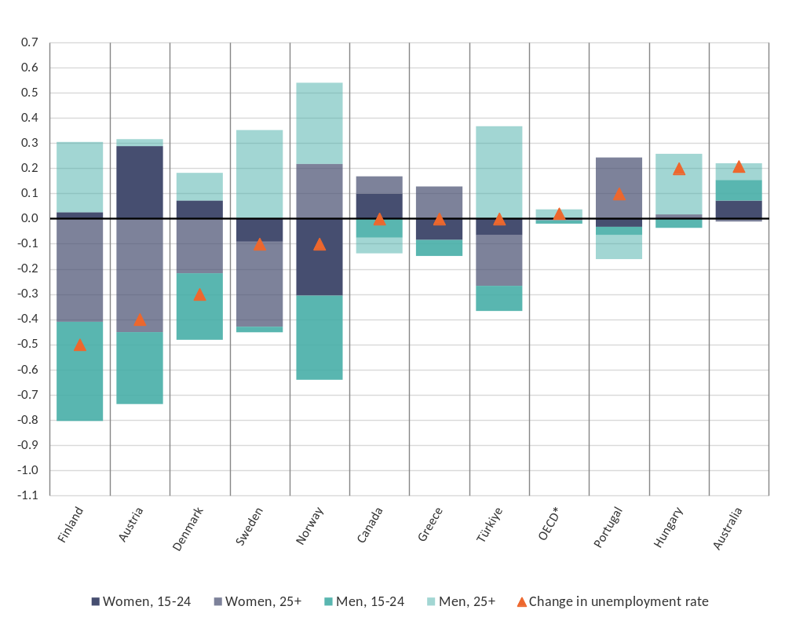 Note: Decomposition of the change in the unemployment rate (all men and women, aged 15+) in September 2025 compared with August 2025 (for the OECD, August 2025 compared with July 2025) by age and sex groups (women, aged 15-24, women, aged 25 and over, men, aged 15-24, and men, aged 25 and over) for selected OECD countries is calculated as describe below:
∆ UNR_T15+_{m/m-1} , change in the unemployment rate, all population, aged 15+, current month compared with preceding month:
∆ UNR_T15+_{m/m-1} = ∑ ( ((UNP_F15_24_{m} / LFP_T15⁺_{m}) - (UNP_F15_24_{m-1} / LFP_T15⁺_{m-1})) *100,
((UNP_F25⁺_{m} / LFP_T15⁺_{m}) - (UNP_F25+_{m-1} / LFP_T15⁺_{m-1})) *100,
((UNP_M15_24_{m} / LFP_T15⁺_{m}) - (UNP_M15_24_{m-1} / LFP_T15⁺_{m-1})) *100,
((UNP_M25⁺_{m} / LFP_T15⁺_{m}) - (UNP_M25⁺_{m-1} / LFP_T15⁺_{m-1})) *100)
with,
$UNP$, Unemployed population by sex (female and male) and age groups (aged 15-24 and 25+),
$LFP_{T15}_{m}^{+}$, Labour force population (unemployed and employed population), all population, aged 15+, with, $LFP_{T15}_{m}^{+} =UNP_{T15}_{m}^{+}+EMP_{T15}_{m}^{+}$
* Due to missing data for Chile, Costa Rica, the United Kingdom, and the United States, September figures for the aggregate for the OECD is not avalaible. For the OECD area, the unemployment rate for August 2025 is reported.
Source: OECD (2025) Infra-annual Labour Statistics, Monthly unemployment rates and Monthly unemployment levels

Table 1 – Unemployment rates (aged 15 and over)
Percentage of labour force, seasonally adjusted
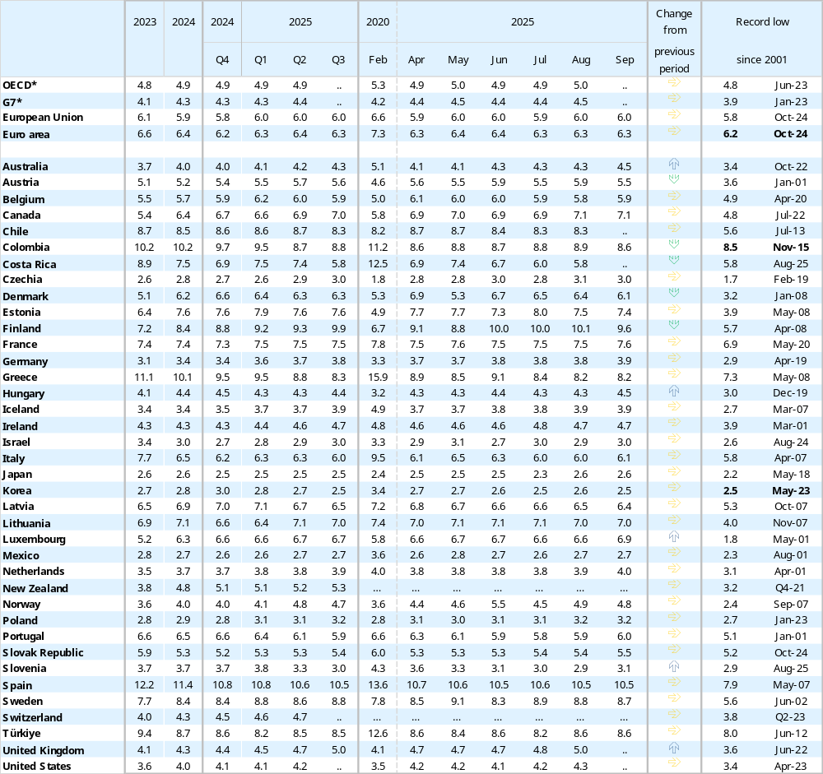
...: Not applicable ..: Not available
* Due to missing data for Chile, Costa Rica, the United Kingdom, and the United States, September figures for the aggregates for the OECD and the G7 areas are not available yet.
Change between August and September 2025 except for Chile, Costa Rica, the United Kingdom and the United States as well as the OECD and the G7, where the change is reported between July and August; for Switzerland, change between first and second quarter 2025; for New-Zealand, change between second and third quarter 2025.
Note: figures in bold in the columns “record low since 2001” stress that the unemployment rate was at or within 0.1 percentage point of its lowest level in the current monthly period.
Source: OECD (2025) Infra-annual Labour Statistics, and Monthly unemployment rates.

Table 2 – Unemployment levels (aged 15 and over)
Thousands of persons, seasonally adjusted
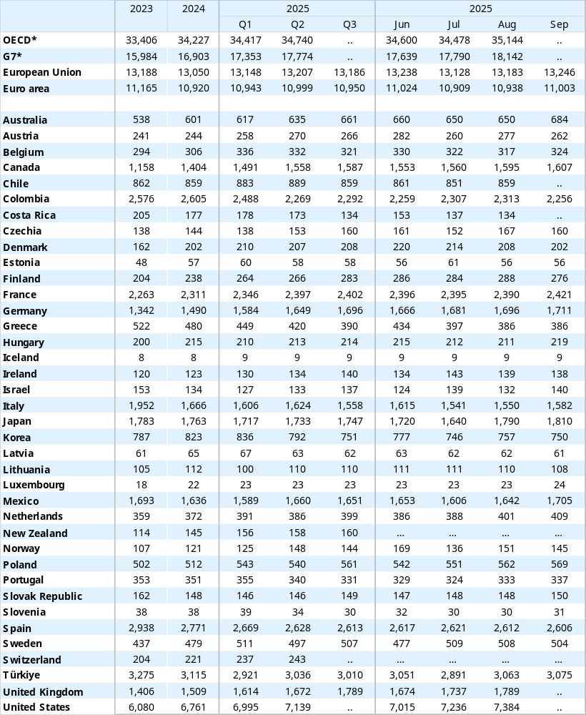
...: Not applicable ..: Not available
* Due to missing data for Chile, Costa Rica, the United Kingdom, and the United States, September figures for the aggregates for the OECD and the G7 areas are not available yet.
Source: OECD (2025) Infra-annual Labour Statistics and Monthly unemployment levels.

Table 3 – Unemployment rates by sex (aged 15 and over)
Percentage of the labour force of each group, seasonally adjusted
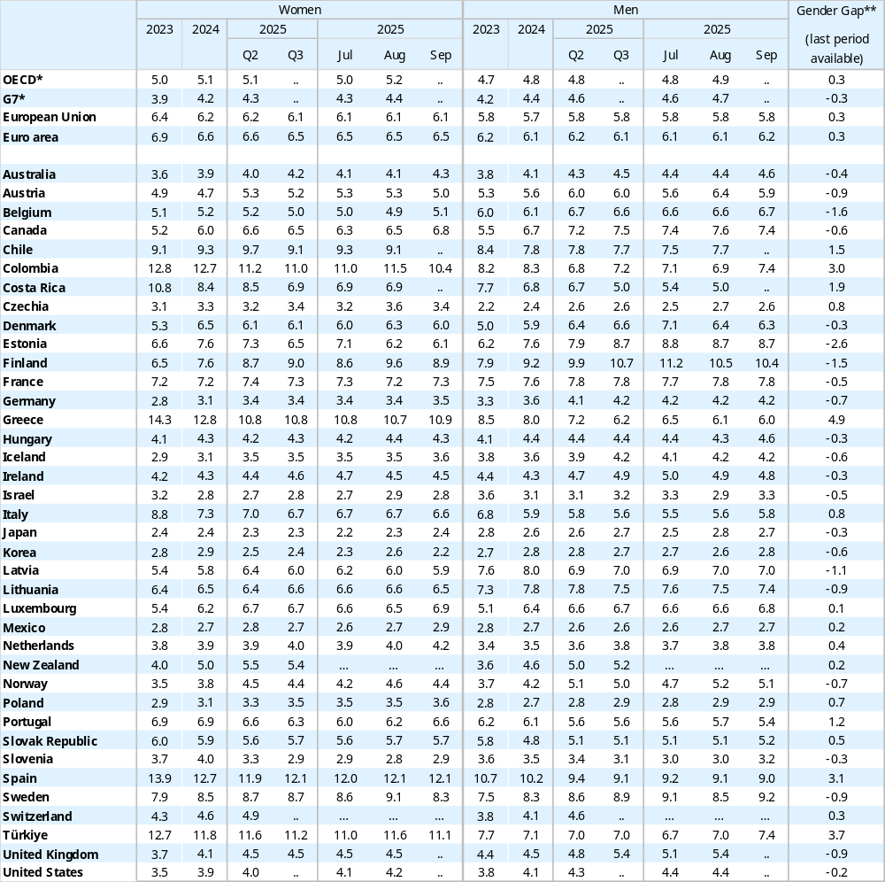
...: Not applicable ..: Not available
* Due to missing data for Chile, Costa Rica, the United Kingdom, and the United States, September figures for the aggregates for the OECD and the G7 areas are not available yet.
**The gender gap is calculated as the difference in percentage points between the unemployment rate for women and men. A positive figure indicates that the unemployment rate for women is higher than for men while a negative figure indicates that the unemployment rate for women is lower than for men.
Source: OECD (2025) Infra-annual Labour Statistics and Monthly unemployment rates.

Table 4 – Unemployment rates by age group
Percentage of the labour force of each group, seasonally adjusted
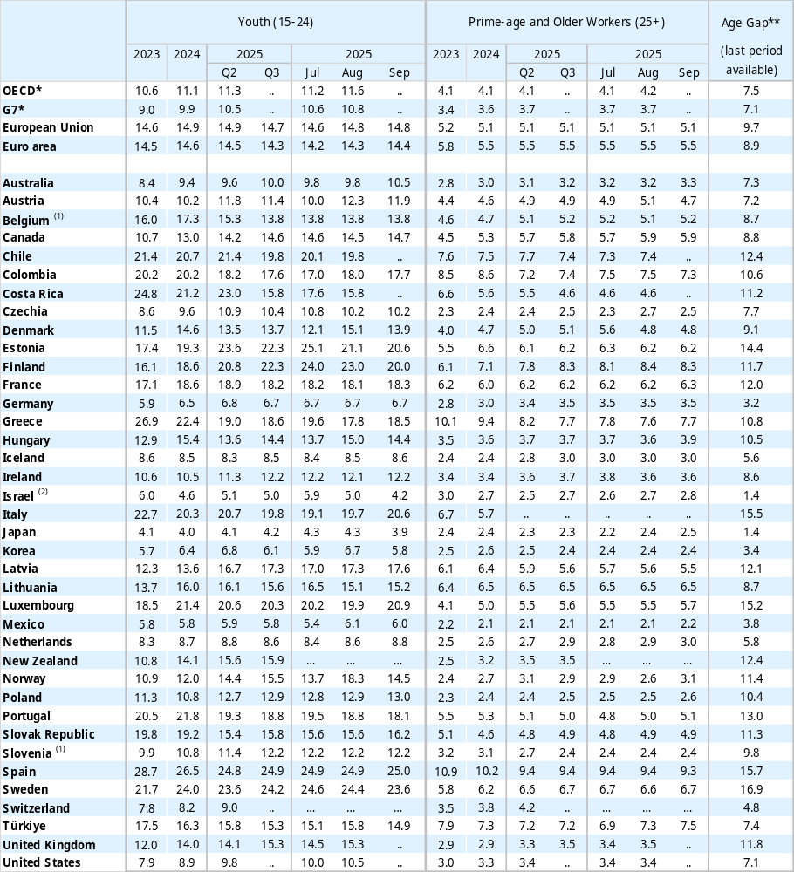
...: Not applicable ..: Not available
* Due to missing data for Chile, Costa Rica, the United Kingdom, and the United States, September figures for the aggregates for the OECD and the G7 areas are not available yet.
** The age gap is calculated as the difference in percentage points between the youth unemployment rate (aged 15-24) and the unemployment rate for prime-age and older workers (aged 25+). A positive figure indicates that the youth unemployment rate is higher than that of prime-age and older workers, while a negative figure indicates that the youth unemployment rate is lower.
Note: 1. Belgium and Slovenia: For youth unemployment, quarterly data are shown for all the months in the quarter.
2. Israel: Data shown in this table are not seasonally adjusted.
Source: OECD (2025) Infra-annual Labour Statistics and Monthly unemployment rates.
Methodological information:
The OECD unemployment rate is calculated as the total number of unemployed people in all OECD countries as a percentage of the total labour force (i.e., the unemployed plus those in employment).
For countries for which unemployment data for the most recent month or quarter are not available, the latest available data are used to compile data for the OECD total.
All rates and levels are seasonally adjusted (s.a.).
For further methodological information, including the impact of COVID-19 on employment and unemployment statistics, see: Methodological Notes for OECD Unemployment and Labour Market Situation News Releases
Access Data:

OECD Database (2025): Infra-annual Labour Statistics
The entry into force in 2021 of the Integrated European Social Statistics (IESS) Framework Regulation resulted in a new methodology of the EU Labour Force Survey, updating the definitions of the labour status. Information by country on the status of the implementation of IESS regulation as well as on possible resulting breaks in time series can be found in a Eurostat Statistics Explained article.
Statistical data for Israel are supplied by and under the responsibility of the relevant Israeli authorities. The use of such data by the OECD is without prejudice to the status of the Golan Heights, East Jerusalem and Israeli settlements in the West Bank under the terms of international law.
Contacts:

For further information contact the OECD's Media Relations Division on (33) 1 45 24 97 00 or e-mail news.contact@oecd.org; for further information on data contact OECD’s Statistics and Data Directorate: stat.contact@oecd.org.

Next releases:

Unemployment: 11 December 2025

Labour Market Situation: January 2026

